**Microprocessor and Interfacing – CSE2006**

**Module 6 – Coprocessor**

1. **Architecture of 8087 coprocessor**

**Architecture of 8087**

The PIN diagram of 8087 Math Co-processor is given in Figure 1.

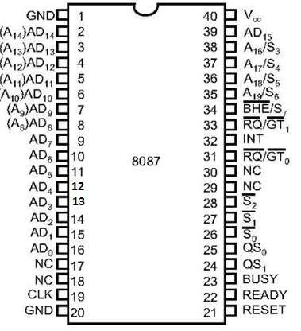

Fig. 1 Pin diagram of 8087 math co-processor.

Source: [https://www.tutorialspoint.com/microprocessor/microprocessor_8087_numeric_data_processor.htm as on 08/07/2020](https://www.tutorialspoint.com/microprocessor/microprocessor_8087_numeric_data_processor.htm%20as%20on%2008/07/2020)

The internal architecture of 8087 math co-processor is given by Figure 2.

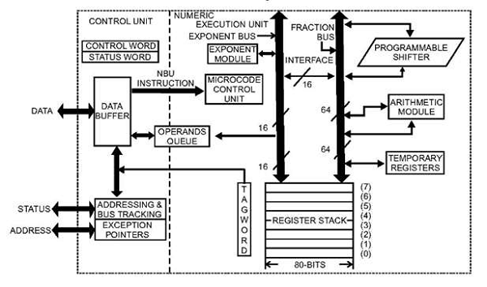

Fig. 2 Internal Architecture of 8087 math co-processor.

Source: [https://www.tutorialspoint.com/microprocessor/microprocessor_8087_numeric_data_processor.htm as on 08/07/2020](https://www.tutorialspoint.com/microprocessor/microprocessor_8087_numeric_data_processor.htm%20as%20on%2008/07/2020)

The architecture of 8087 has two main units as follows:

1. Control Unit
2. Execution Unit

**1. Control Unit**

The main aim of the control unit is to synchronize the operations of the microprocessor and co-processor. The main components of this unit are the Control Word, the Status Word and the Data Buffer. If the given instruction is a co-processor instruction, then, the co-processor executes it, otherwise, the microprocessor executes it.

**Status Register**

The overall operation of the coprocessor is tracked by the status register.

|  |  |  |  |  |  |  |  |  |  |  |  |  |  |  |  |
| --- | --- | --- | --- | --- | --- | --- | --- | --- | --- | --- | --- | --- | --- | --- | --- |
| B | C3 |  | ST |  | C2 | C1 | C0 | ES |  | PE | UE | OE | ZE | DE | IE |

Each entry of the status register is explained as follows:

1. C3-C0 - Condition code bits
2. TOP - Top-of-stack (ST)
3. ES - Error summary
4. PE - Precision error
5. UE - Under flow error
6. OE - Overflow error
7. ZE - Zero error
8. DE - Denormalized error
9. IE - Invalid error
10. B - Busy bit

The busy bit tells that the coprocessor is busy with a task. The status of BUSY can be known by using the FWAIT instruction. C3-C0 indicate the condition code bits, that indicates the conditions of the coprocessor. TOP is the Top of the stack (ST) bit which gives the current register address as the top of the stack. The ES is the Error Summary bit. It is set if any of the error bits specified by PE, UE, OE, ZE, DE, or IE is set. In the 8087 the coprocessor interrupt is also caused error summary.

PE is the Precision error which indicates a certain precision is used for the result or operand. The UE is Under flow error which indicates that the outcome is very large to be represented by the currently selected precision. OE is Over flow Error that indicates the result is too large for representation. The ZE is a Zero Error which says that the divisor is ‘0’ when a dividend is a non-infinity number or a non-zero number.

DE means denormalized error which says that at least one among the operands is denormalized. IE is invalid error which indicates that a stack overflow or underflow has occurred. E.g, taking square root of a negative number.

**Control Register**

The control register selects the appropriate control signals namely, precision, rounding control, infinity control. In order to load values into the control register, instruction FLDCW is used.

|  |  |  |  |  |  |  |  |  |  |  |  |  |  |  |  |
| --- | --- | --- | --- | --- | --- | --- | --- | --- | --- | --- | --- | --- | --- | --- | --- |
|  |  | IC |  | RC |  | PC |  |  |  | PM | UM | OM | ZM | DM | IM |

**Control Register**

1. IC - Infinity control
2. RC - Rounding control
3. PC - Precision control
4. PM - Precision control
5. UM - Underflow mask
6. OM - Overflow mask
7. ZM - Division by zero mask
8. DM - Denormalized operand mask
9. IM - Invalid operand mask

**Infinity Control**

The infinity control selects affine (+ve or -ve infinity) or projective infinity (infinity is unsigned). If it is ‘0’ 🡪 It is Projective, If it is ‘1’ 🡪 Affine

**Rounding Control**

RC refers to Rounding control which determines the type of rounding.

00 🡪 Round to nearest or even

01 🡪 Round down towards minus infinity

10 🡪 Round up towards plus infinity

11 🡪 Chop or truncate towards zero

**Precision Control**

PC refers to Precision control that sets the precision of a result.

00 🡪 Single precision (short)

01 🡪 Reserved

10 🡪 Double precision (long)

11 🡪 Extended precision (temporary)

**2. Execution Unit**

This performs the operations that access the numeric data available in the registers of the co-processor. The Numeric Registers are 80 bits wide. They are present in the NUE which is capable of performing arithmetic, logic and transcendental operations. It can also supply small mathematical constants from its ROM.

**Weblinks**

1. <http://www.idc-online.com/technical_references/pdfs/electronic_engineering/8087_Co_Processors_and_Architechture.pdf>
2. <https://www.tutorialspoint.com/microprocessor/microprocessor_8087_numeric_data_processor.htm>